Sustainable Development in T&T and the Caribbean.
(National Innovation Systems)
By: B. Copeland, R. De Four, S. Gift and St.C. King
(Research and Innovation Focus Group, Faculty of Engineering)

Abstract:
The work on the economic models of the region and in particular T&T has had wide intellectual exposure- the ideas of the plantation economy and recently the Dutch Disease with respect to the exploitation of the T&T’s petroleum resources. The fact that these natural resources are depleting is at least one reason why the economy has to be diversified, another is that a petroleum based economy is subject to external shocks, though Peak Oil at present suggests the maintenance of high petroleum and petroleum based product prices in the medium term.

However, diversification of T&T's, and those of the Caribbean at large economy, is not a new idea but to date this has proven difficult to accomplish. The authors suggest in this paper that economic diversification in today's globalised economy depends not on continued increase in productivity in the exploitation of our economic factors but in continuing increases in innovation in the creation of products and services. The Caribbean as developing countries does not have the institutions that make up a National Innovation System, a vehicle that is necessary if the actors are to be effectively integrated. The paper also describes how such an Innovation System can be put together in T&T and the Caribbean region.

Although the paper refers to the National Innovation system only a few of its processes are described in any detail because of a limit on presentation time.

An Objective

The end of the EU Lome agreements, scheduled to be replaced by the EPA, has set the stage for the Caribbean economies to restructure themselves into knowledge based wealth generating economies, that are globally competitive- creating enterprises that produce tradable goods and services and providing sustainable jobs and returns on investment. Caribbean economies must successfully take on this challenge to survive in the future. Much of the literature on Caribbean economic development refers to the building of a knowledge based society (see footnote). However, this is a much larger, longer and total society transforming task than what this paper sets itself- the creation of knowledge based economy, a microcosm of such a society, as an initial step in the larger process. As a result the knowledge based economy accepts that present society will dynamically provide its inputs and creates/modifies institutions and processes focusing on economic development.

History has taught us that this will not come about unless there is a direct intervention by the major economic stake holders; governments, private sectors, R&D institutions and the general public.

A Wealth Generating Economy

A wealth generating economy continually produces knowledge, inventions, prototype products, services and enhances natural resources, private sector entrepreneurs, SMEs that use these inventions etc. to make marketable products and services and marketing and market development systems that provide a link between the producers of knowledge and the entrepreneurs, with the demands of the market.

A simplified illustration of this process is shown in Figure 1 below. A pyramid structure is used to indicate the relative sizes of the human resource required to make each level work. The structure shows that the knowledge generating component feeds new concepts, inventions and other creations to the “lower” levels that shape and modify them for commercialization. Income earned is then used to fund activities at the higher levels. Significantly, in the Caribbean there is little or no product and process creation or development so that the process is disjointed. Interestingly, the UWI emphasis on research can be seen as activity at the very top of the pyramid. However, the incompleteness of the structure renders this activity useless as part of the region’s wealth generation mechanism. Unlike what occurs in the developed nations, Caribbean research is funded almost solely by the taxpayer. If one adds to this the loss of copyright that goes with the traditional publication motive, it is seen that this activity provides further top level support to countries with complete wealth generation structures at the expense of Caribbean taxpayers.

More specifically, rapidly developing countries are increasing the proportion of their GDP allocated to knowledge generation and to fostering links among the different players in the production process- current estimates are about 2.8% for the USA and Japan, 2.4% for OECD countries, 2.1% for S Korea and 1.2% for Brazil- that for the region as a whole is of the order of 0.016%. This allocation in the Caribbean to research and development has resulted in some undirected research taking place, the results of which have been made available to the international and local academic communities through the publication process. It must be noted that very little or none of the knowledge generated in CARICOM countries from the funding of research has been utilized in inventions, innovations, technology transfer to business and industry to drive economic growth and development, thereby allowing the region to be globally competitive as a result of these research activities.

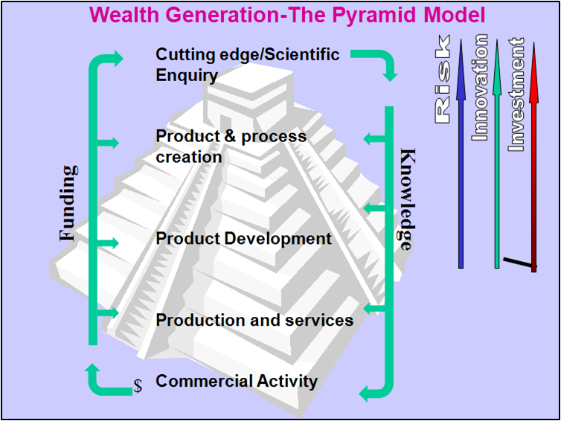

Fig. 1: The Pyramid Model for an Economy Based on Technological Innovation

The wealth generating economy is underpinned by a financial system that facilitates savings, investments as venture capital, corporate venturing, and transfer of equities - really changing cash earned by the production system into capital (production assets) that feeds the further development of the economy. Its non-tradable support systems in part ensure the efficient performance of the Innovation System, e.g. good health care, adequate physical infrastructure. Taken together they all form the National or Regional Innovation System.

The Regional Economic Challenge – Innovation System Creation

CARICOM Governments are clearly cognisant of a missing mechanism in the development process, and have been sensitive to this for some time. For example, the Caribbean Council for Science and Technology (CCST) CCST is an intergovernmental organisation that seeks to promote cooperation in science and technology among its member countries acting through their respective national science councils. Also, At the 20th Meeting of CARICOM Heads of Government held in July, 1999 in Trinidad, it was agreed in principle to establish a dedicated funding agency to support research, knowledge generation and innovation in the region. Further the Caribbean Council for Science and Technology prepared a report for CARICOM, ‘Science and Technology and Innovation’ in March 2007. However, Caribbean initiatives to date have met with little success. Regional Innovation systems are clearly the missing mechanisms in Caribbean countries for wealth generation using knowledge as the input ingredient.

Caribbean regional economies, without Innovation Systems as defined, have been characterised by economists as “plantation economies”, and are now under severe stress and are more vulnerable than ever as a result of globalisation. Therein foreign investments are generally utilised to exploit regional resources and the region benefits from “rents” and other incidental incomes that provide the funds to import most of what it consumes.

The region now has to create a mechanism that transports it from this current position to a knowledge based economy that is sustainable. Developed economies, identified as knowledge based societies, have diffused innovation systems and already possess the characteristics defined for such systems - universities and R&D institutions that produce the knowledge and human capital, journals that disseminate the knowledge, mature stock markets and financial systems, marketing and market development systems. The region needs discrete Innovation Systems as immediate precursors to the wider aim of creating a knowledge-based society via a knowledge base economy.

Current wisdom tells us of the need to create Innovation Systems that include the knowledge generating system (UWI etc), but must include other external (to UWI) linkages and systems (Fig 2). These include entrepreneurs, funding agents (grants, venture capital, corporate venturing) the market, all co-ordinated by state-private-sector-university management systems.

The Innovation System requires financing of D&R and encouraging local entrepreneurs to take risks of creating new clustered firms. Sir Arthur Lewis tells us of the reluctance of the regional entrepreneurs to move out of commerce – buying and selling at the lowest level of the pyramid in Figure 1 – into the more difficult task of developing industries. In general these existing companies have no interest in conducting or sponsoring local D&R. Hence, the private sectors have to be recreated.

In the developed countries, the private sector is the driver of economic development and its financing (T&T’s private sector is mainly about the production of non-tradable goods). We have also seen that in emerging countries such as Korea, Israel, and Chile, governments play, initially, the defining role in creating the innovation system, particularly in grant and venture capital financing and creating the necessary institutions.

R & D Input Sectors to Innovation

The economic development of the region depends on the creation of knowledge and its application to the entrepreneurial process – the creation of globally competitive enterprises. In general, the entrepreneur of the region has to innovate in business methods and exploit the natural advantages and structured advantages of the region.

Natural advantages are those that occur naturally in the region; tropical agricultural, natural resources, tourism. However, these can only be exploited globally and competitively, if the region creates and applies new knowledge to making high added value products/services. i.e. the region should not export cocoa beans in crocus bags, or cheap labour or sun – sand – sea tourism.

Business innovation is the quickest of all to accomplish but its Intellectual Property (IP) is the most difficult to protect. It is about finding new ways to conduct existing businesses and even create new businesses e.g. the Internet business Google, local airline industry and the like.

Exploitation of natural advantages through the application of knowledge can take place reasonably quickly as was the case of salmon farming in Chile, wine production in Australia, tourism in Dubai.

Structured advantages depend on the exploitation of IP created in the country, either in new areas (particularly those of emerging concern) or those already known internationally. The Intellectual Property created is what makes these new firms globally competitive. However, developing an industry based on structured advantage takes a long time. For example, in Korea the creation of the CNC industry took decades.

Innovation Systems

An Innovation System requires Centres of Excellence. These centres are established to exploit a few technologies and create knowledge advantages. They include business development facilities (not funded on a project by project basis) e.g. Dubai’s centre for alternative energy, SMEs, entrepreneurs in clusters who can exploit the opportunities created by the Centres or provide D&R ideas to the Centres; a Financing system that provides, physical and human resources, D&R grants, seed money, Venture Capital and encourages Corporate Venturing; and the creation of a local Test and Adopted Market that can be used in feedback and feed-forward modes to inform the SMEs and Centres. These form the four points of the Innovation Diamond (shown in Figure 2), the model of the recommended Innovation System.

There should also be coordinating institution(s) to integrate and network the four interacting Innovation Diamond Points, consisting of the private and public sectors and the Centres’ strategic development staff. If any of these items is missing then the knowledge creating effort will contribute little to regional economic development.

Fig. 2: The Innovation Diamond

LEARNING, R&D
SYSTEMS: UWI
CENTRES OF
EXCELLENCE
Finance; Grants,
Venture Capital,
Corporate
Venturing
Test Market.
Mkt. Intelligence
Entrepreneurs
SMEs, Corporate
Expansion
Institutions

Innovation System (IS) Processes

In the construction of an Innovation System, the Innovation Diamond, the following processes have to be engaged upon:

Knowledge development and Diffusion; Universities, Centres of Excellence and IS Support services.

Search for Activities re Natural and Structured advantages, and Business Innovations: - Governments, Private sector and Universities

Entrepreneurial activity; use new knowledge to improve and build products and services. - Centres of Excellence and SMEs

Market Development, standards development, performance criteria, demand development, price: Government assistance in adopted markets, IP management development, control of local market to provide local space for testing and building capacity

Legitimation; building social acceptance, political will to mobilise resources

Resource mobilisation; venture capital, corporate venturing, finance system development, training of human resources

Transfer of knowledge and commercial activities from Centres and Universities to private sector

Intellectual Property development and management

Innovation System Support Services

The Innovation System is focused on creating a knowledge based economy. However an economy cannot thrive if the security of the person is threatened by out of control crime, or if the local health service is inadequate, or if the electricity, water and telecommunications services are poor or the human resource needs specialised training etc. The establishment of these support services can also benefit from the creation and application of knowledge in these areas, but they are not tradable services in the first instance.

In a developing country many of these services need to be addressed. The priority should be given to those that directly affect the initial creation of the knowledge economy.

The Innovation System then must work with the authorities to manage and fund the knowledge creation for these support systems. The diverse researchers from the universities of the region should then be expected to bid for such projects.

The following are examples of support services:

Social, economic and legal studies as they relate to crime, security and justice

Health and wellness

Natural hazards management, disaster risk management

Climate change and sustainable development

Governance and management of the Caribbean Sea

CSME integration studies

Teacher training

Water, electricity, telecommunication and transport systems

It is expected that some projects envisioned by the Centres of Excellence at its chaotic end will be contracted out to the traditional university researchers.

\

Finance Mobilisation

There is a very powerful example of the impact of institutionalised finance, in fact risk alleviation by lender, even at the poorest level of society, on economic and social development – The Grameen Bank

Today this bank, founded by Dr Mohammed Yunus in 1976, has some US$32.2billion lent out in micro credit with the average loan being US$150 and expected to grow to several thousands of dollars in the future. A recent conference theme was: ‘It takes a Bank to grow a village’; institutionalised finance is fundamental to social and economic development.

The Developed World: Finance

The innovation financial system in the developed world is highly organised into stock and bond markets, venture capital, corporate venturing, angel investors, government funding and willing stock market investors who take risks.

In innovation driven systems, based on knowledge, the availability of investment capital via the above is crucial in funding start-up companies as is the existence of innovative entrepreneurs.

Example: today after the rush to manufacture ethanol as an alternative fuel, it is recognised that this may not be the ultimate answer because it mixes with water impeding transport. The hope is for cellulose based bio-fuels that overcome the drawbacks of ethanol. Hence there is a new set of innovative firms working to perfect the process for large scale production of these fuels. These firms benefit from massive venture capital since they will see no income maybe for years.

Of importance also is the opportunity for venture capitalists to exit their investments via the stock market and the facility to offer IPOs, fundamental to the innovation system

The stock market also plays a role in ensuring market efficiency of the listed companies and also is a means of raising capital for further expansion.

The Caribbean Region: Finance

The region is an example of a plantation economy characterised first by the design of an economic system, then the implementation of its society (Lloyd Best). It is living proof that foreign investment does not necessarily drive economic development- wealth creation.

Normally as a society develops it also develops its economy. It then attempts to supply as many of its needs as possible, exports its surplus and eventually turns to specialisation doing what it can do best for export and imports, for what it is not competitive. In so doing the socio-economic system develops financial and regulatory institutions that support the efforts to produce its goods and services.

The region’s plantation economies had their creation in foreign investment in tropical agriculture for export and imported labour for the farms. The plantation economy imported the goods and services necessary to support the plantation and its workers as did the indigenous financial systems to facilitate import and distribution. The original banking system was foreign owned though there were attempts to develop indigenous systems to encourage thrift and savings in the workers- unlike the Grameen bank. These failed.

What little manufacturing existed was grounded in import substitution, then regional exports under tariff barriers. Some hope that the EPA will encourage manufacturing for the global market.

The local banking system is not about indigenous economic development operating in parallel with the plantation economy- venture capital, support of R&D, innovation.

A corollary to this is that the regional private sector and regional private capital see their investment opportunities in import and distribution activities, particularly in non-tradable goods and services as lucrative and low risk alongside the plantation economy.

Sir Arthur had this to say: Local capitalists know very little about industry. They are specialists in agriculture and commerce. In general the local capitalists are simply not interested in doing the hard pioneering work of new manufacturing industries’.

Another of Sir Arthur’s comments has to do with- if not our present capitalists who else? This is the basis of the laissez-faire philosophy wherein it is generally felt that in capitalist societies that if anything is worth doing then someone will do it. If no one does it then it cannot be worth doing and the effort of the government to get it done must be contrary to public interest.

Hence some say that governments should stay away from the initialisation of the production of new goods and services.

The situation has worsened in T&T since the plantation economy morphed into the Dutch Disease in which even the little export manufacturing is collapsing into increasing production of non tradable goods and services. Globalisation has also contributed in the region to the destruction of industry- bananas.

The T&T Government sees then that it has to use its earnings to fund local expenditure in priority social projects- so increasing GDP. The private sector then positions itself to benefit handsomely from this expenditure. Even the UWI initiative into commercialisation of its R&D via an IDB loan failed dismally without an innovation system.

To many the present regional economic model is not an efficient or effective mode of economic development even if the region’s natural resources were infinite.

A Proposed Dynamic Finance Model

The region needs a new finance model if it is to spawn knowledge based economies. The initial point on the trajectory of this model is no funding to support venture capital, nor corporate venturing, nor R&D grants from the present risk averse private sector. Government funding is small and undirected re economic development. The endpoint target of the model is a private sector, government, education sector combination that provides the above funding. The model trajectory has to overcome the reluctance of the private sector to fund these innovative entrepreneurs and be convinced that they can make large returns on investment.

The Intermediate Points on the Trajectory have to Include:

Government funding from say the RSF in T&T for R&D grant funding of the Centres of Excellence,

Government offer of bonds to the national bond market and further divestment of these bonds on the secondary bond market is a key facility.

Use of the funds collected under these bonds as inputs into venture capital funds for potential knowledge based SMEs, via in particular those of UWI’s Centres of Excellence- the Government borrows at low interest rates and takes the risk to invest these monies in high risk venture capital.

In effect the private sector is investing in venture capital but the Government covers the higher risks.

Returns to Governments on VC funds used to repay bonds and to help establish Venture capital funds from which further allocations can be made to innovative entrepreneurs.

Sale of Government and UWI shareholding in the SMEs via IPOs in the stock market- so improving the thin markets of the region.

Private sector acquisition of shares in the innovative SMEs via the stock market.

The end point of the trajectory sees the private sector encouraged to take over the direct VC investment from Governments and UWI since they would have seen that the immediate benefits from the sale of the IPOs are superior to the returns in the medium to long term of the SMEs on the stock exchange.

The private sector would have seen the benefits of investment in R&D and would seek to do the same as Governments.

Dynamic Finance Model Stages
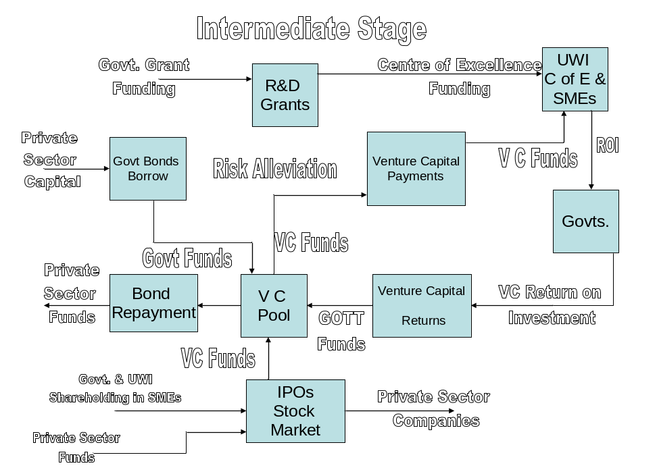

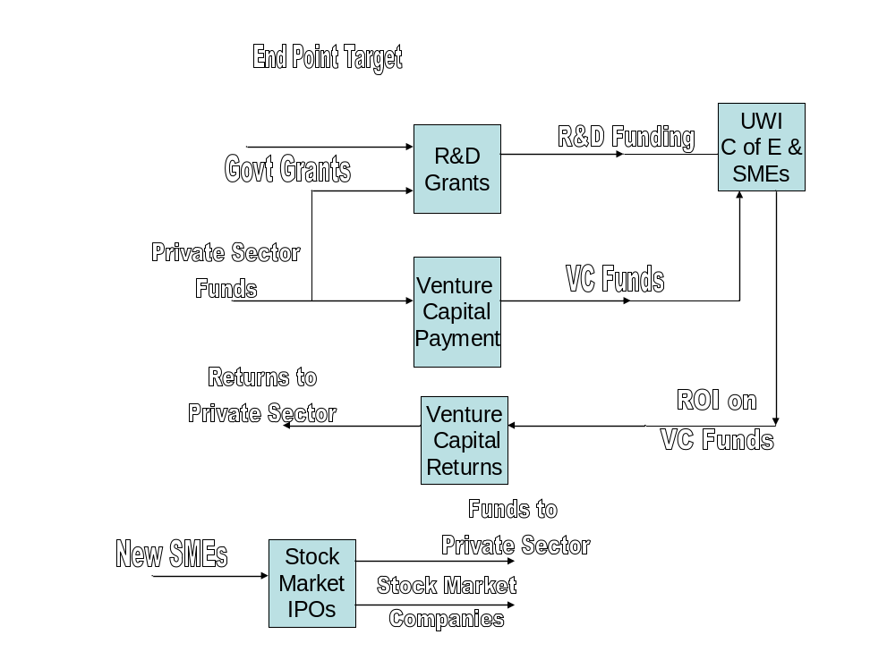

Figure 3 Finance Models

Financial Management Institutions

There has always been concern about the even handedness of allocation of investment funds by Governments to deserving candidates especially if the criterion is for their use in efficient economic development. This concern has been raised with respect to the management of the SWFs of the petroleum exporting countries by the OECD, for example. Hence it is recommended that these Government funds be managed, as is the RSF, by a group of professionals who understand the policies and objective of the investment funds. These professionals should come from the private sector, the Central Bank, though hired by the Governments, but subject to minimal day to day direction. Universities should not sit on these management groups since they are clients of the funds.

12.Intellectual Property Development and Management
The created Intellectual Property (IP) is the driving force of the innovation system. Hence this process of the Innovation Diamond has to be properly governed, co-ordinated, managed via a legal framework and fueled by researchers, inventors and financial investors including governments. Further, the process has to provide an adequate reward system for the contributors to the creation and exploitation of IP (Profit Centered Players).

The innovation system diamond shows the need for various co-ordination institutions one of which should have the direct responsibility across the whole system for IP- creation, exploitation, reward mechanisms called the Office of IP Management (OIPM), Figure 3. The OIPM must provide IP policies for the innovation system processes- knowledge creation and development, knowledge exploitation (via SMEs etc), Marketing and trade law and financiers. These policies should provide the structure for the generation, exploitation, ownership, protection, co-ordination and management of IP that characterises the innovation system. Such policies must be guided by the international IP conventions (Berne and Paris conventions, WIPO, PCT Treaty, and TRIPS), the national/regional IP laws, the laws incorporating the institutions of the innovation system and the contractual agreements among the players and their staff. These policies must be integrated to minimise the conflicts among the participants which will take place in an area of law that itself is innovatively evolving (e.g. Ambush Marketing!).

The primary function of the innovation system is to generate wealth through the creation and exploitation of knowledge and facilitation of the reward structure via the OIPM for the profit centered players.
Figure 3 Intellectual Property Institution
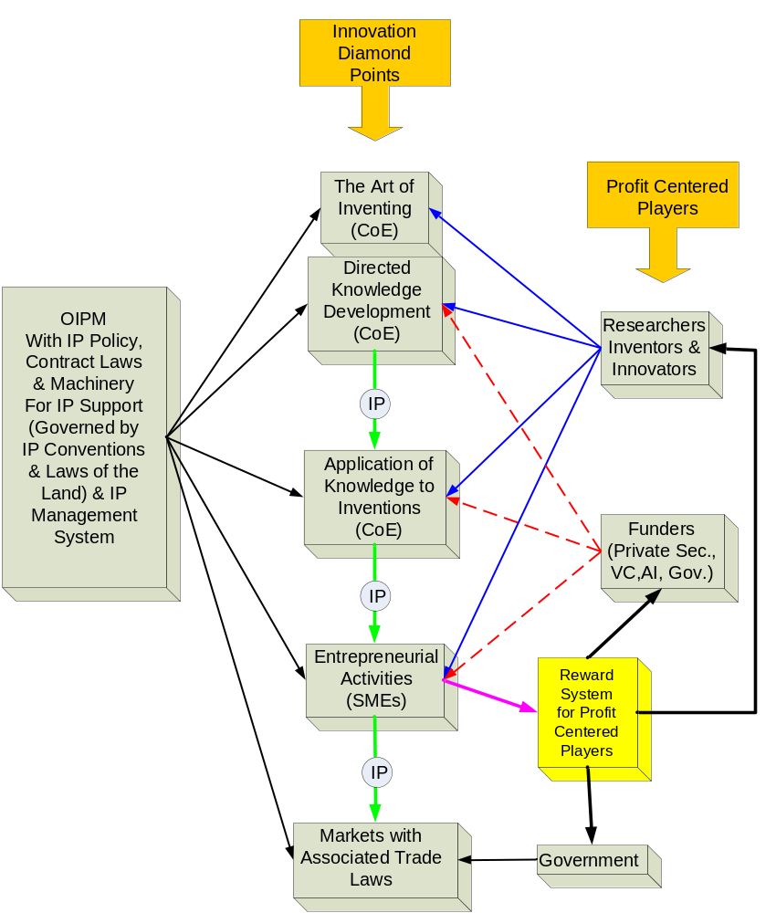

Knowledge Creation
This is one of the prime activities of the centres of excellence. It is worth noting that a fundamental training activity of these centres is in the area of ‘the art of inventing’ which is directed not only on research per se, but on research and development geared towards commercial exploitation. The form of IP at the level of the centres of excellence is two fold- patent rights and copyrights. In the traditional university’s undirected research the aim appears to be to publish- the IP of concern is copyright which is in most cases traditionally handed over to the publisher. Since the creation and exploitation of knowledge in the innovation system focus on the commercialisation of new products and services, patent rights and copyrights (the latter as applied in certain jurisdictions to software) are pertinent and to be effectively exploited must be protected and properly managed nationally, regionally and internationally. Further, the players at this level of knowledge creation must be adequately rewarded based on their contracts etc. subject to the various IP laws and conventions.

Though the centres of excellence may indeed take the knowledge created and transform it into innovative products and services, these also represent patentable and copyrightable products that depend on, possibly, existing patents in the “prior art”. Hence new products have to possess their own IP in the form of patents, trade secrets, trademarks, and copyright- all protected via the mechanisms of the OIPM. Given the need to perform in the global market this IP protection has to be sought in all industrial and culturally aligned states whose production entities could be global competitors. This broad coverage of IP protection is facilitated by the Patent Co-operation Treaty (PCT) that allows the simultaneous protection of inventions in all PCT contracting states- a time and money saving vehicle in the patenting process. The patenting process requires well trained lawyers and agents and training courses in IP management are mushrooming world wide. Fundamentally, the IP claim should satisfy these three conditions- novelty, invention and industrial/commercial applicability. The procedure is standardized globally requiring similar legal competence among the network of IP lawyers.

Entrepreneurial Activity and Reward System
The IP, from the application of knowledge to inventions, is released to entrepreneurial activities via a manufacturing licence agreement. This agreement rewards the inventor and assignee (usually the funders of the initial inventive work) by royalties for the use of the IP and sale of the product. In the actual manufacturing process by the entrepreneur other IP may be generated that includes, process and manufacturing know-how, trade secrets and trademarks- all of which again have to be protected.

Markets and Trade Law
The innovation cycle is complete when the finished product or service enters the market place and is sold to make a profit in the investment. However, these international markets are governed by various trade agreements (WTO, FTAA?, EPA etc) made by governments of the region. It is therefore incumbent in the trade negotiators to ensure that these agreements do not contain in particular IP clauses that can restrict the entry of the products of their innovation systems from being developed or entering the targeted international markets.

Beneficiaries
The profit centered players include researchers, inventors, innovators, funders and governments- al make integrated and invaluable contributions to the innovative process. The process can be severely hampered, if not forestalled, if even one of these is absent. For example the unavailability of venture capital funding in the region is a major drawback in the required innovation process. Hence the IP policy of the OIPM must precisely state the policy for the entitlement of each to the rewards of the generated IP.

UWI’s Proposed Role in the Innovation System

There are three activities that should be of interest to UWI and these are:

As designer of and facilitator to the establishment of the Regional Innovation System and its continued management

As a host for Centres of Excellence which will require UWI to provide specialist staff and facilities in the areas chosen by the foresighting exercise and

Providing research staff for addressing, and to manage the Innovation Support Services activities. These activities will be separate and distinct from that of the Centres of Excellence though linked and will fit into the university’s normal research activity

Expected Outcomes

Legitimation by Heads of Government, a buy-in to this proposal for national or regional innovation systems

Recommendations for modifications of the Innovation System model.

Instruction to UWI to prepare project proposals with all the implications including financial on the following:

Legitimation exercise for regional private sectors

Legitimation exercise for the region’s general publics

Proposal for a regional foresighting exercise to identify optimal emerging technologies that suit the region, identifying natural advantages to exploit and the priority IS support services.

Planning in general for the infrastructure for a Centre of Excellence

Planning for a regional Centre of Excellence for agriculture production

Establishment of an institution to plan, implement and coordinate the whole exercise

Establishment of Governments’ and Private sector bodies to plan and implement the new financial and marketing systems

Establishment of a Public Relations group to continually inform and sell the ideas to the public

© 2008 Copeland, DeFour, Gift and King
Research and Innovation Focus Group

The paper addresses this in the context of what is often termed a knowledge-based society- “… an innovative and life-long learning society, which possesses a community of scholars, researchers, engineers, technicians, research networks, and firms engaged in research and in production of high-technology goods and service provision. It forms a national innovation-production system, which is integrated into international networks of knowledge production, diffusion, utilization, and protection. Its communication and information technological tools make vast amounts of human knowledge easily accessible. Knowledge is used to empower and enrich people culturally and materially, and to build a sustainable society.” Source: http://www.sciforum.hu/index.php?image=update&content=up_knowledge_based_society, The World Science Forum, Budapest, 8-10 November 2003, site accessed May 18 2008

